Enjoy the Journey
Blog #32

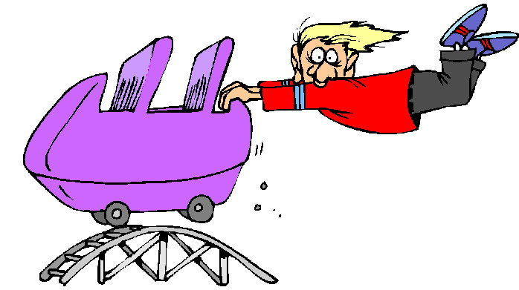

Even in my 50’s, I am still enjoying the journey of life and the lessons it brings. The best life decision I made was becoming an entrepreneur (which was second to being a Mommy). It has given me exposure to worlds of business and people that I may never have met or see. It has allowed me to be in the right place when it comes to my daughter and family. All because I chose a street that was not traditional at the time.

Guess what? That street introduced me to people just like me. Mavericks, Innovators, Trailblazers, people of all walks of life and the main thing we all have in common is that we refuse to settle for the status quo. The good news is that the community in which I live now brings the support I longed for and the latitude I craved to allow me to be me.

As women we are phenomenal at reinvention and whether it is transitioning into entrepreneurship or aggressive career moves or just being a Mommy. The reward in all of the decisions required in growing up is that we keep ourselves engaged and our minds sharp.

“Presently, I am encountering so many wonderful adventures that I see no light at the end of the tunnel. It is truly a fantastic journey of discovery.”

